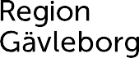

REGIONAL CULTURE PLAN GÄVLEBORG
2023–2026 in an easy way
- 4 questions on 2 pages
A committed art and culture life for sustainable development

What is a region?
In Sweden there are 21 Regions.  Region Gävleborg is one of them.  A Region handles project which cost so much that areas larger than the municipalities need to collaborate.  Region Gävleborg is responsible, for example for:  ● health and medical care, such as hospitals  ● public transportation, such as busses and  trains  ● creation and experiences which are important for the cultural life in the county. | 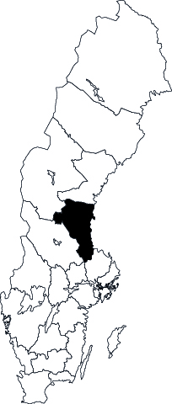

What is a regional culture plan?

In order to get a picture of the needs that culture has in Gävleborg county, Region Gävleborg has spoken to many people at various meetings. These are people from the county's municipalities and others who work with culture or who are part of associations. The conversations are the basis of the regional culture plan, a document that depicts the situation today and what will be most important to work on in the next 4 years. Everyone was given the chance to be involved and make an impact. Region Gävleborg drawing up a regional culture plan so more people can experience and create culture and make the county a good place to live or visit.

To receive government money, Region Gävleborg sends the plan to the Cultural Council. The Cultural Council is the government authority which ensures that national culture policy becomes a reality in Sweden.

Region Gävleborg carries the state money forward to regional culture institutions* who works with the culture plan.

What does the regional culture plan for Gävleborg County 2023-2026 state?

● The culture plan tells us about 5 things which are important for culture:

- children and young people have the right to culture
- the people who work with culture must follow democratic rules
- all people are of equal value
- de those who create culture are free to think, express their ideas and create without any restrictions
- those whose profession is to work with culture must be paid reasonably

● The culture plan also lays out the importance of thinking and working sustainably. It implies working so
that we can meet today's needs without jeopardizing the ability of future generations to meet their needs.

The regional culture plan has 3 important orientations for the period 2023-2026:

- those who work with or give money to culture must talk and collaborate with each other and also with
others in society
- culture is for everyone
- growth and culture interact in several ways for the development of a sustainable society

● The culture plan describes how the 8 points above look like in the following areas:

- theatre, dance, music
- archives, museums, World Heritage Decorated Farmhouses of Hälsingland
- libraries
- literature
- arts and crafts
- film
- cross media. The story is most important and can mix different expressions. It can be games, social media,
movies or books. The audience is most often involved in creating.

*What are the regional culture institutions in Gävleborg county?

In Gävleborg county, the following 7 regional institutions are:

● Arkiv Gävleborg - arkivgavleborg.se
● Folkteatern Gävleborg - folkteaterngavleborg.se
● Gävle Symphoni Orchestra - gavlesymfoniorkester.se
● Hälsinglands museum - halsinglandsmuseum.se
● Kultur Gävleborg, Region Gävleborg's culture department - regiongavleborg.se/kultur
● Länsmuseet Gävleborg, The County Museum - lansmuseetgavleborg.se
● Riksteatern Gävleborg - riksteatern.se/gavleborg

Each institution develops, among other things, activities and programs suitable for children and young people.

The regional culture institutions collaborate with municipalities, associations, artists and others who work with culture in Gävleborg county.

